LIBRARY MANAGEMNET SYSTEM:

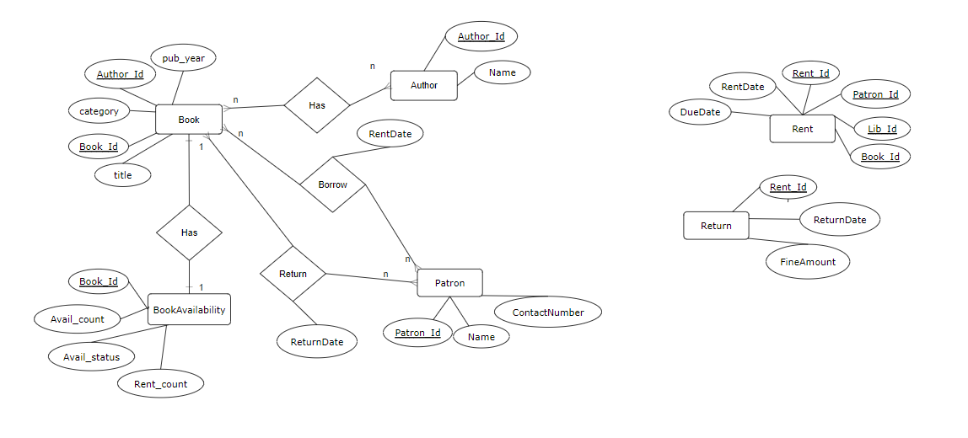

Library Management system

Book-bookld, title, category, authorld, publishedyear

BookAvailability- bookld, availCount, availStatus, rentCount

Patron - patronld, name, contactNumber

Author-authorld, name

Rent-rentld, patronld, bookld, rentDate, due Date

Return-rentld, return Date, fineAmount